**Step 1:**

Create New ASP.NET Empty Web Application

Templates -> Web -> Visual Studio 2012 -> ASP.NET Empty Web Application

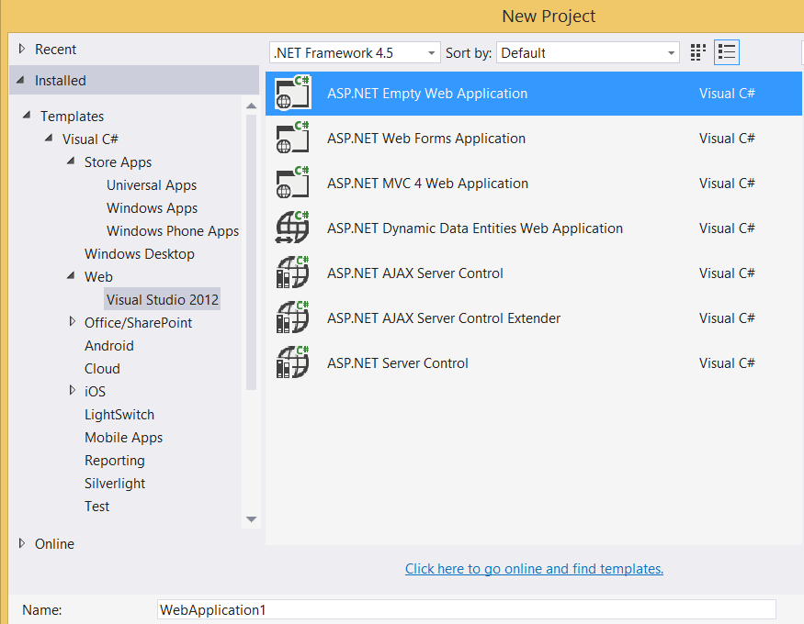

**Step 2:** Add New WebForm Page

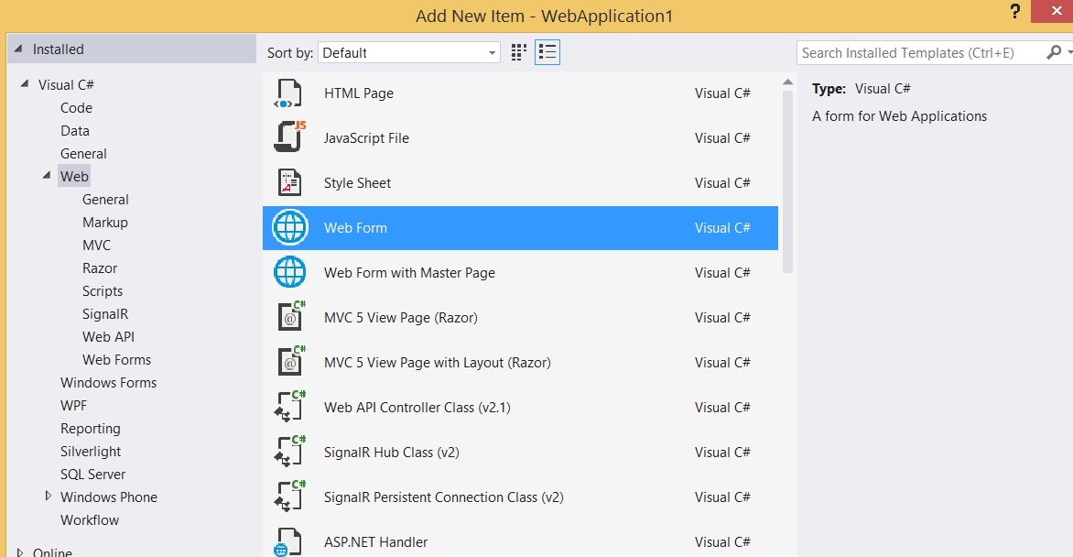

**Step 3:**

Add one button & file upload control in WebForm1.aspx page also add async=”true” at first line

<body>

<form id="form1" runat="server">

<div>

Photo Upload : <asp:FileUpload ID="fuTest" runat="server" />

<br/>

<asp:Button ID="btnUpload" Text="Upload File" runat="server" OnClick="btnUpload_Click"/>

<asp:Label ID="lblPhotoUpload" Text="Click on Upload File button" runat="server" />

</div>

</form>

</body>

**Step 4:**

Right click on project name and select “Manage NuGet Packages…”

Search for “Azure Storage”

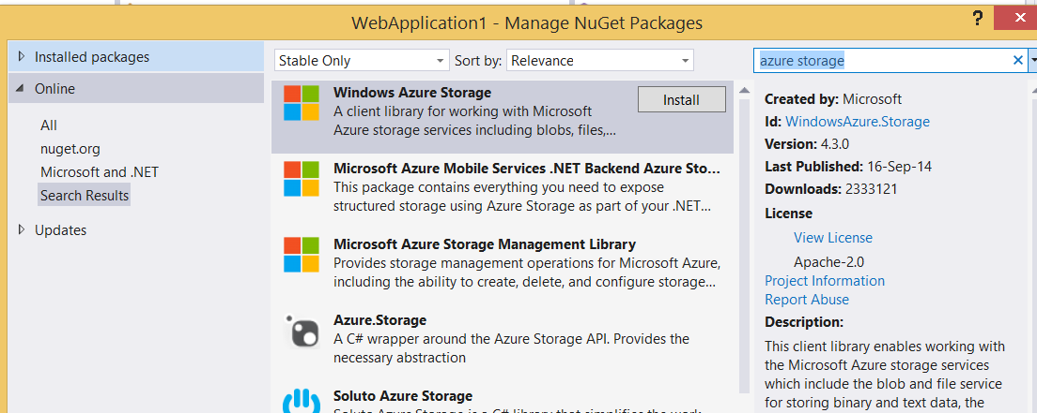

Install the Package.

**Step 5:**

Open WebForm1.aspx.cs

Add the reference of Azure storage

using Microsoft.WindowsAzure.Storage;

using Microsoft.WindowsAzure.Storage.Auth;

using Microsoft.WindowsAzure.Storage.Blob;

protected void Page_Load(object sender, EventArgs e)

{

}

protected async void btnUpload_Click(object sender, EventArgs e)

{

// Retrieve storage account from connection string

CloudStorageAccount storageAccount = new CloudStorageAccount(

new StorageCredentials("storagename",

"storageaccesskey"), true);

// Create the blob client

CloudBlobClient blobClient = storageAccount.CreateCloudBlobClient();

// Retrieve reference to a previously created container

CloudBlobContainer container = blobClient.GetContainerReference("photocontainer");

await container.CreateIfNotExistsAsync();

CloudBlockBlob blockBlob = container.GetBlockBlobReference(fuTest.PostedFile.FileName);

// Create or overwrite the "myblob" blob with contents from a local file.

using (var fileStream = fuTest.PostedFile.InputStream)

{

blockBlob.UploadFromStream(fileStream);

}

lblPhotoUpload.Text = "Photo Uploaded Successfully.";

}

Now run the project



Image successfully uploaded



Using Azure Storage Explorer

